Ysgol Gynradd Cwmpadarn

Adroddiad Blynyddol y Llywodraethwyr i’r Rhieni 2013-14 Governors’ Annual Report to Parents 2014

THE ANNUAL MEETING

The annual meeting of the Governing Body with the parents was not held during the 2013-14 academic year. This is as a result of the School Standards and Organisation (Wales) Act 2013, which came into force on 4 May 2013, noting the governing body is no longer required to hold an annual parents meeting. However, the Act allows for parents of registered pupils at the school to request up to three meetings per year with the governing body via a petition. A brief summary is provided below.

The governing body will hold the meeting within 25 school days of receiving the petition, providing that:
1. the petition contains the signatures of the required minimum number of parents of registered pupils at the school, which is the lower of the following:
(a) the parents of 10% of registered pupils, or
(b) the parents of 30 registered pupils.
2. the meeting requested by parents must be to discuss a matter relating to the school.
3. there will be no more than three meetings held during the year in which the first petition is received.
4. there are sufficient school days left in the school year for the meeting to be held.

MEMBERS OF THE GOVERING BODY

NAME | STATUS | TERM OF OFFICE
Mr Ben Davies | LEA Representative | 29/01/17
Cllr. Gareth Davies | LEA Representative | 04/05/17
Mr Andrew Price | Parent Governor | 30/01/16
Mrs Heather Hickin | Parent Governor and Chair | 25/10/17
Cllr. Linda Keeler | Community Governor | 09/09/16
Mr Jack Evershed | Community Governor | 17/06/16
Mrs Kathleen Gaskell | Teacher Governor | 27/02/19
Mr Huw Raw Rees | Head teacher Governor | -

THE NAMES AND ADDRESSES OF THE CLERK AND CHAIRPERSON

Clerk to the Governors: | Ms Pauline Lucas  Manager Client Services Education and  Community Services Department  Ceredigion County Council  Canolfan Rheidol  Rhodfa Padarn  Llanbadarn Fawr  Aberystwyth  Ceredigion  SY23 3UE
Chair: | Mrs Heather Hickin  Roslyn  Bath Street  Aberystwyth  SY23 2NN
2 governors were elected to the governing during 2013-14

THE NUMBER OF UNAUTHORISED ABSENCES AND AUTHORISED ABSENCES IN THE REPORTING SCHOOL YEAR EXPRESSED AS A % OF THE TOTAL OF POSSIBLE ATTENDANCES

Attendance figures for 2013 – 2014
School Summary | Sessions | %
Authorised Absence | 975 | 4.01%
Present | 23044 | 94.73%
Unauthorised Absence | 307 | 1.26%
Total | 24326 | 100%

Attendance statistics – girls / boys
Girls | Authorised Absence | 3.85%
 | Present | 94.52%
 | Unauthorised Absence | 1.63%
Boys | Authorised Absence | 4.18%
 | Present | 94.95%
 | Unauthorised Absence | 0.87%

- The most recent school comparative information in relation to the school’s performance in end of foundation phase assessments published by the Welsh Ministers on DEWi.
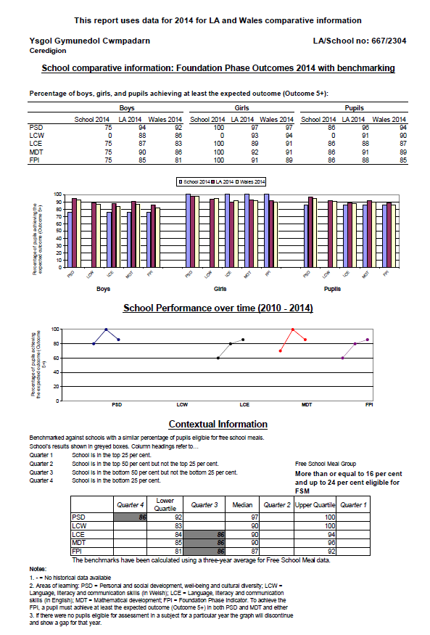
- The most recent school comparative information in relation to the school’s performance in end of key stage 2 assessments published by the Welsh Ministers on DEWi.

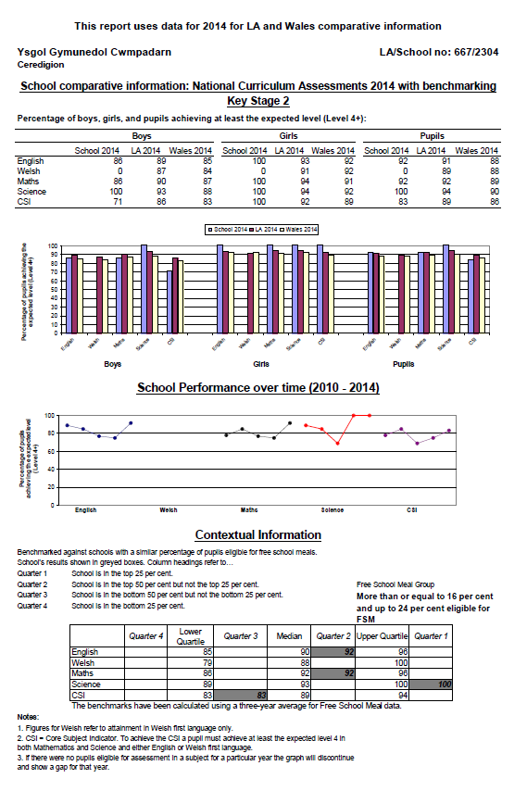
INFORMATION REGARDING TARGETS FOR SCHOOL IMPROVEMENT

The most significant document regarding school improvement is the School Development Plant. The School Development Plan is written in order to set targets and prioritise spending. For the year 2013-2014 SDP focused on the following issues –

- Raise standards in key areas in to the Foundation Phase and KS 2
- Continue to review the intervention support for pupils within: Foundation Phase / Below 85 and Mathematical intervention.
- To target individual groups to ensure that they reach the expected level
- Increase the opportunities to develop Assessment for Learning (across the curriculum) within Mathematics and Numeracy e.g. pupils self-assessment and peer evaluation.
- Work with the LEA School Inclusion Officer to monitor and target attendance of pupils between 85%-90 %
- To continue to work closely with the ‘Athrawon Bro’ service to improve standards in Welsh throughout the school.
- Improve Whole school Monitoring

FINANCIAL STATEMENT FOR THE YEAR 2013-2014

Employee Costs | £215,256
Premises Costs | £19,635
Transport Costs | £798
Supplies and Services | £33,521
Gross Expenditure | £269,210
Income | -£12,665
Net Expenditure | £256,543
Rev Formula Funding 13/14 | £256,888
Balance b/f 1 April 2013 | £33,144
Total | £290,032
Total Held In Reserve 2012/13 | £33,489

COMMUNITY LINKS

Our school plays a very important part in the local and wider community. This includes the individual school community, the community within which the school is located, as well as other Welsh and global communities.

We ensure that the school’s curriculum and ethos promotes a common sense of identity and supports diversity, showing pupils that different communities can work together to develop a coherent and successful society, for example, developing international links through forging and developing links with partner schools across Europe. The school has successfully completed its two year Comenius project with its partner school, with staff visiting schools in Finland, France and Ireland, with over 30 pupils from Penrhyncoch and Cwmpadarn visiting Saint Mertin’s School in Ireland. By doing this the school promotes:
- The development of partnership arrangements to share good practice and offer pupils the opportunity to meet and learn from pupils from different backgrounds.
- Links built into existing schemes of work, with pupils working together on joint projects.
- Shared use of facilities to provide opportunities for different pupils to interact.
- Links with schools outside the local area through EU and international projects.
In addition pupils parents and staff have raised funds for the following orgqanisations throughout the year.

- Poppy Appeal £ 37.00
- Toilet Appeal £ 60.00
- Save the Children £ 55.00
- Cerebral Palsy £ 40.00

Funds raised through Staff and School Council promoted events:

- Summer Fayre £ 250.00
- Disco £ 114.24
- Easter Fayre £ 167.44

The After School Club also received additional fundig from:

Children & Family Information Services £2231.99

VISITORS TO SUPPORT THE CURRICULUM

- Mr. Brian Davies KS 1 & KS 2 supported pupils D.T
- Mark Williams MP ECO Flag presentation
- Rev Andrew Herrick Harvest Festival
- Gwyndaf Lloyd Fire Brigade Service
- Arad Goch Drama Workshop
- Sea Watch Foundation
- Mike Barrat Football Training
- Matthew Brown Penglais Transition
- Health Visitors Foundation Phase
- Matthew Brown Penglais Transition
- Bible Explorer Year 5 & 6
- EAL
- Reverend Loat Whole School Assembly
- RNLI Whole School Assembly
- Morrison’s Easter Prizes re: paintings

Our School Council elected committee representatives for 2013 / 2014 are:
- Year 6 Kaitlin Jenkins
- Year 6 Lewis Price
- Year 5 Isabel Hoare
- Year 5 Liam Lloyd
- Year 4 Reuben Price
- Year 4 Amber Edwards
- Year 3 Rocco Morgan
- Year 3 Summer Forrester
- Year 2 Eliza Cooper
- Year 2 Sean Lloyd

Additional links within the community involved the following activities:

With support from parents, staff, school council and PTA the children experienced the following activities during the last week of term:

- Cinema Visit to see Despicable Me 2
- Christmas Fayre
- Christmas Dinner
- Children’s Entertainer Mr. Barry Riding
- Visit from Father Christmas
- Children’s Party
- Llanbadarn Horticultural Society

ACTION TAKEN TO PROMOTE HEALTHY EATING AND DRINKING

Ysgol Cwmpadarn has been accredited with Phase 4 of the Healthy Schools Scheme. The assessors were shown around the school and the school grounds by the school council

They noted that the school was very good at:

· Inviting specialist people into school.
· Making sure that all pupils are involved in a variety of activities.
· Teaching pupils about the importance of keeping safe and healthy.
· Listening to pupils ideas and suggestions for improvement—poster competition.

The school is part of Ceredigion’s ‘Health Promoting Schools’ initiative and makes every effort to ensure that pupils learn these key life skills in a fun and practical way. Within the Healthy School initiative themes are targeted within the school and an action plan created to develop aspects further on a whole school level: nutrition being one of the main aspects.

The school is working on the final stage of the Eco-Schools project which is a programme which provides a framework to enable the school to become more sustainable. The project encourages teamwork and helps to create a shared understanding of what is needed in order to run a school in a way that respects and enhances the environment.

SUMMARY OF THE SPORTS PROVISION INCLUDING PROVISION MADE FOR EXTRACURRICULAR SPORTS ACTIVITIES

Autumn Term:
- Area Football Tournament @ Rhydypennau
- Castell Henllys Year 3 & 4
- Spri Diri F. Ph.
- Cross Country KS 2
- Film Festival / Safety First KS 2
- Film Festival /The Tale of Desperado F.Ph
- Dragon Multi Skills Year 5 & 6
- Young Ambassadors:
  - Kaitlin Jenkins
  - Lewis Price both Year 6 & School Councillors
- Christmas Cinema Visit Despicable Me 2
- Y 5 6 National Library
- KS 2 Aber Cycle Fest
- Y 6 Choir practise @ Aberaeron
- Y 6 Penglais Transition
- F. Ph. Ar y Bel
- Y 5 6 Machinations
- School Sports Winners Padarn
  - Victor Ludorum Jack Clement & Kieran Davies
  - Victrix Ludorum Kaitlin Jenkins
- Area Sports
- Y 6 Ceredigion Choir in the Great Hall
- Y 3 4 Glan y Mor
- Y 5 6 3 day Urdd Residential Visit
- KS 2 Diwrnod Hwyl yr Urdd
- Whole School Macmillan Dance & Own Clothes
- Y 6 Leavers Assembly and Tea
- Y 6 Leavers Party
- Bronze Ambassadors’ presentation held at Plascrug

• School dates, including holidays, for the next academic year;

Term | Begin |  | End​ | ​Total School Days
Autumn2014 ​ | Tuesday  2 September  2014 | Half Term  Monday 27 October 2014 - Friday 31 October 2014 | ​ Friday  19 December  2014 | ​74
Spring 2015 | ​ ​Monday  5 January  2015 | Half Term  Monday 16 Feb 2015 - Friday 20 February 2015 | ​Friday  27 March  2015 | 55
Summer 2015 | ​Tuesday  14 April  2015 | Half Term  Monday 25 May 2015 - Friday 29 May 2015 | Monday  20 July  2015 | ​55
Plus directed teachers' closure days Monday 1 September 2014 & Monday 13 April 2015 |  |  |  | Total ​195

CURRICULUM STATEMENT

Our curriculum seeks to ensure that all learners in our school are engaged as full members of the school community, accessing the wider curriculum and all school activities. It is a balanced, broad curriculum that seeks to provide the cultural, moral, social and emotional, physical and mental development of pupils and prepare them for opportunities and responsibilities in adult life.

The Key Components

- The Foundation Phase 3-7 years
- National Curriculum Key Stage 2
- The Literacy and Numeracy Frameworks
- Personal and Social education
- Religious Education
- Y Cwricwlwm Cymreig
- Healthy Schools / Eco / Global Citizenship

INCLUSION

The school aims to ensure that every pupil with additional needs receives a high standard of educational provision and has access to a curriculum that has breadth, balance and relevance. Children who are having difficulties are identified as early as possible and support is then targeted. When a teacher believes that a pupil requires additional support he/she will make a note of any difficulties and discuss the matter with the SENCO and the Head teacher. Parental permission will always be sought before placing a child on the special educational needs register and, where appropriate, the child’s view will also be taken into account.

The school aims to keep parents well informed and invite them to school every term to discuss progress and to comment on their child’s Individual Education Plan. Every teacher is aware of the importance of differentiation in order to provide a full and relevant education to his or her pupils. Depending on the nature of the task, differentiation will focus on the level of the work, marking and praise, expectations and class management, i.e. working in pairs, groups or individually.

CHANGES TO THE SCHOOL PROSPECTUS

The school prospectus is updated and revised every term in order to ensure that the most recent information is included. A copy can be obtained from the Head teacher.

THE LANGUAGE CATEGORY THAT MOST CLOSELY DESCRIBES THE SCHOOL

The school is described as a predominantly English Medium primary school but with significant use of Welsh

Curriculum – Pupils in the Foundation Phase experience the areas of learning in both languages but with greater emphasis on English. In Key Stage 2, both Welsh and English is used in teaching but there is greater emphasis on English. Welsh is used as the medium of teaching or learning for between 20% and 50% of the primary curriculum overall.

Language of the School – The day to day language or languages of the school are determined by the school’s linguistic context. Both languages are used as languages of communication with the pupils and for the school’s administration. A high priority is given to creating a Welsh ethos. The school communicates with parents in both languages.

Outcomes – The normal expectation is that pupils will transfer to English medium secondary provision, but will have attained enhanced Welsh second language skills. Some pupils may be able to pursue a limited number of subjects through the medium of Welsh at secondary level where these are offered.

THE PROVISION OF TOILET FACILITIES AND THE ARRANGEMENTS IN PLACE FOR CLEANING

The toilets are cleaned to an excellent standard.

